1. Creating a generic publisher using JmsTemplate.  
   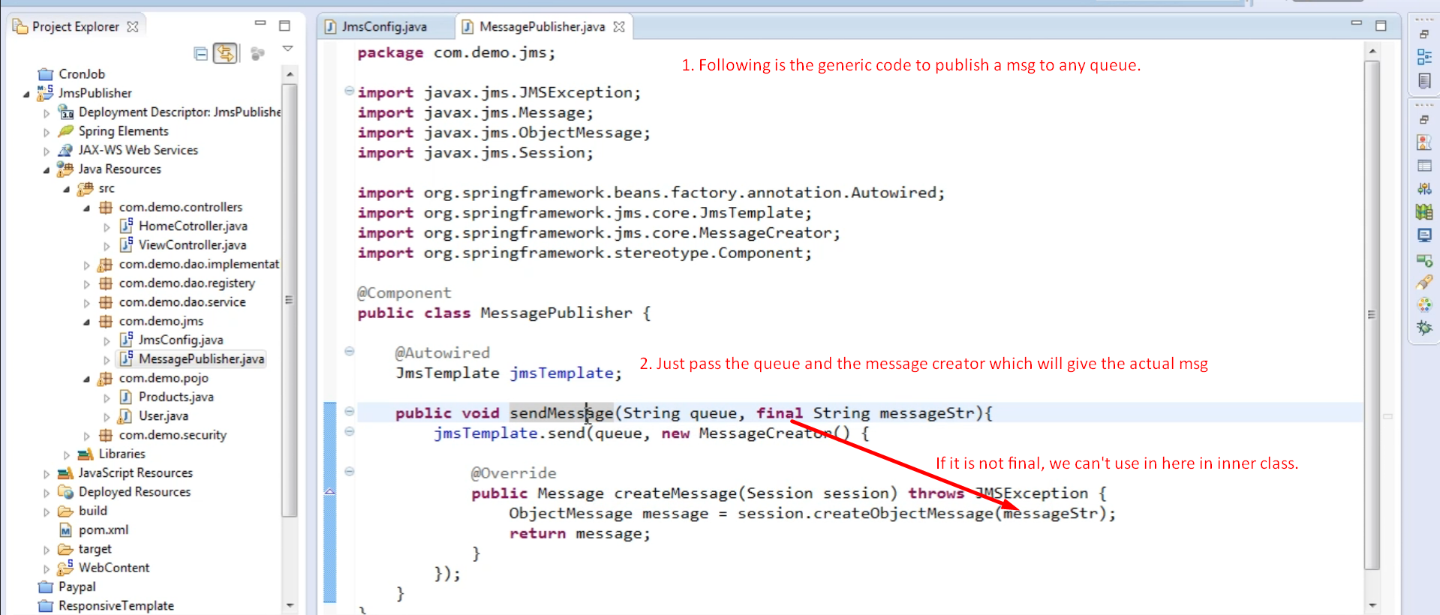
2. Publishing msg.  
   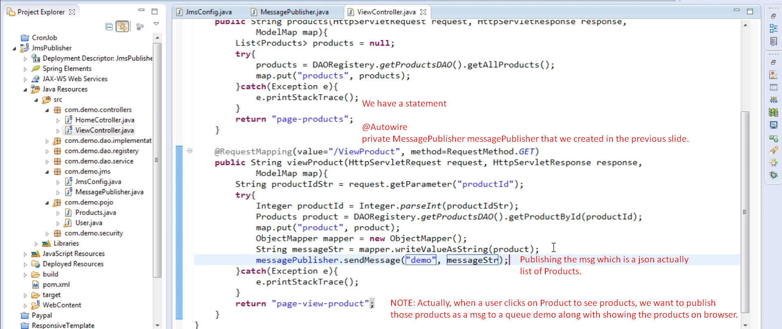
3. 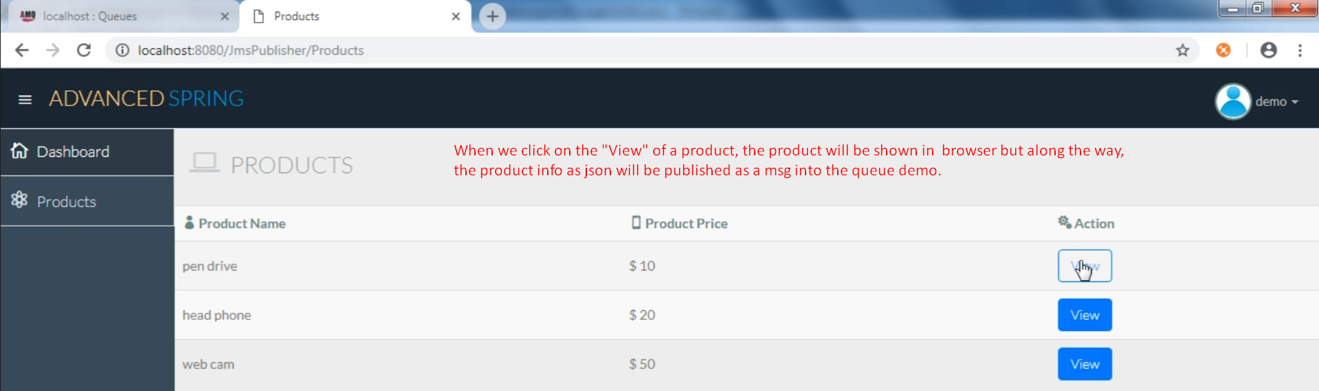
4. Graphical user interface, application

   Description automatically generated
5. Let’s attach a consumer in the next lecture.